Assignment-1

Write a brief summary on SDLC. Explain each phase.

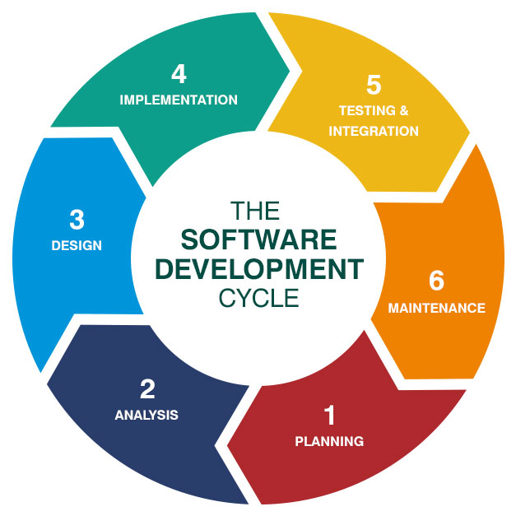

->Software development life cycle (SDLC) is a structured process that is used to design, develop, and test good-quality software.

->Software development life cycle, is a methodology that defines the entire procedure of software development step-by-step.

-> The goal of the SDLC life cycle model is to deliver high-quality, maintainable software that meets the user’s requirements.

Planning-Architect will plan and come with a project proposal to the client.

Analysis-The architect will analyse the model in which language it should be developed ,in which platform it should be deployed and how many servers are need when we go live.

->If it is ok with the planning and analysis we will move on to design part.

Design-Here the software engineers will develop the code for the above requirement planning and analysis.

Testing & Integration-The testers will test the code if the code runs properly or if any bugs are there again the design team will develop the code.if code runs without errors we will Go Live.

Maintenance-If Go Live have any bugs the Maintainance team will resolve the problem.